**Comprehensive YouTube Influencer Analysis Report**

**Executive Summary:**

This report delves into a detailed analysis of a dataset containing information about YouTube influencers. The objective is to gain insights into their performance metrics, engagement rates, audience preferences, and potential marketing opportunities. By understanding these aspects, businesses can formulate effective strategies to engage with their target audience and maximize their reach.

**Introduction:**

The dataset comprises various metrics related to YouTube channels, such as average views, likes, comments, and subscriber counts. Additionally, categorical data like 'Category' and 'Audience Country' provide insights into content genres and geographic audience preferences.

**Data Overview:**

* **Dataset Description**:
  + **Size**: The dataset contains several columns and thousands of rows, offering a comprehensive view of multiple YouTube channels.
  + **Features**: Metrics include 'avg views', 'avg likes', 'avg comments', 'Subscribers', 'Category', and 'Audience Country'.

**Data Cleaning and Preparation:**

* **Handling Missing Values**:
  + Rows with missing values in 'avg likes' or 'avg comments' were removed to ensure the reliability of the analysis.
  + Remaining null values were checked and addressed to maintain data integrity.
* **Numeric Conversion**:
  + Columns like 'avg views', 'avg likes', and 'avg comments' were converted to numeric types for accurate calculations and analysis.
* **Standardizing Subscriber Counts**:
  + Subscriber numbers were standardized by converting string values like 'M' for Million and 'K' for Thousand to actual numeric values, facilitating consistent analysis.

**Key Metrics Analysis:**

* **Engagement Rate Calculation**:
  + Engagement Rate (ER) was calculated to gauge the interaction level between the influencers and their audience.
  + **Formula**: ER=(Engagement AverageTotal Followers)×100ER=(Total FollowersEngagement Average​)×100
  + **Significance**: A higher engagement rate indicates that the content is resonating well with the audience, potentially leading to increased visibility and audience growth.

**Data Visualization and Insights:**

* **Content Category Distribution**:
  + A bar chart was created to visualize the frequency of each content category, helping identify popular content areas.
  + Insights can be drawn to understand content trends and audience preferences across different genres.
* **Audience Country Distribution**:
  + Another bar chart showcases the distribution of audience countries, revealing geographic audience preferences.
  + This information is crucial for targeting specific regions in marketing campaigns and tailoring content to meet regional preferences.
* **Category Demand Analysis**:
  + For the 'Education' category, a bar chart was generated to display the demand in different countries.
  + This analysis aids in understanding the popularity of educational content across various regions and identifying potential growth opportunities.

**Detailed Analysis:**

* **Top Performing Channels**:
  + Channels from various countries are present in the dataset, with Spain emerging as a notable contributor.
  + Detailed analysis of Spain's channels can offer insights into successful content strategies and audience engagement techniques.
* **Audience Preferences and Geographic Insights**:
  + Channels from Spain predominantly focus on specific content categories, indicating regional content preferences.
  + Geographic insights highlight potential markets for expansion and audience targeting strategies.
* **Engagement Insights and Content Resonance**:
  + Channels with higher engagement rates signify content that resonates well with the audience.
  + Understanding these channels can provide valuable insights into content creation and audience engagement best practices.

**Technical Results:**

The above figure depicts the Data Frame `df_y` contains information about various YouTube channels, including the YouTuber name, channel name, category, number of subscribers, audience country, and average engagement metrics like views, likes, comments, and engagement rate. The data is sorted based on the number of new subscribers in descending order, with T-Series leading the list with 212.1 million new subscribers, followed by Cocomelon - Nursery Rhymes with 132.1 million.

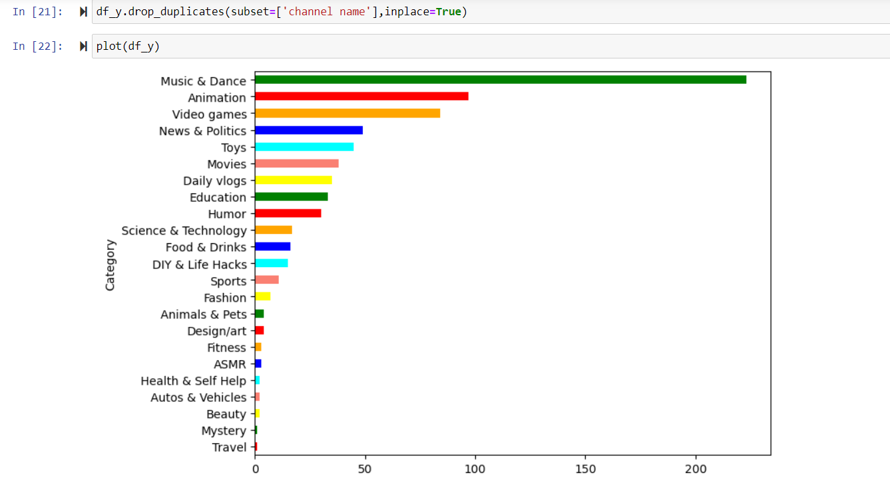

The code removes duplicate rows based on the 'channel name' column from **df_y** and suggests plotting the cleaned data, though the plot type isn't specified. Engagement rate : the Percentage of Followers who really engages with the content posted by Influencers.

The code and data displays the first 10 rows of **df_y**, which includes columns like 'youtuber name', 'channel name', 'Category', 'Subscribers', 'Audience Country', 'avg views', 'avg likes', 'avg comments', and 'Engagement_Rate'. It also shows some top YouTube channels primarily from India with their respective subscriber counts and engagement metrics.

**Conclusion and Recommendations:**

* **Content Impact and Engagement**:
  + A high engagement rate suggests that the content is impactful and resonates with the audience.
  + Emphasizing content quality and relevance can further enhance engagement and audience satisfaction.
* **Marketing Opportunities and Strategy Formulation**:
  + Insights from the analysis can guide marketing strategies, helping to target specific content categories or geographic locations effectively.
  + Tailoring marketing campaigns based on audience preferences and content trends can lead to better engagement and higher ROI.

**Recommendations for Future Actions:**

1. **Content Strategy Optimization**:
   * Focus on content categories with high demand and engagement rates to attract a broader audience and increase viewer retention.
2. **Audience Targeting and Expansion**:
   * Consider Spain and other regions with active channels as potential markets for expansion.
   * Tailor content and marketing strategies to meet regional preferences and enhance audience engagement.
3. **Engagement Boost and Audience Interaction**:
   * Implement strategies to encourage more audience interaction, such as Q&A sessions, polls, and contests.
   * Foster a community-like environment to build stronger connections with the audience and enhance content resonance.